Task level insights:

Task 1: You have moved to a new home and need to change your address on file with TRS. Where would you check to find out how to do this?
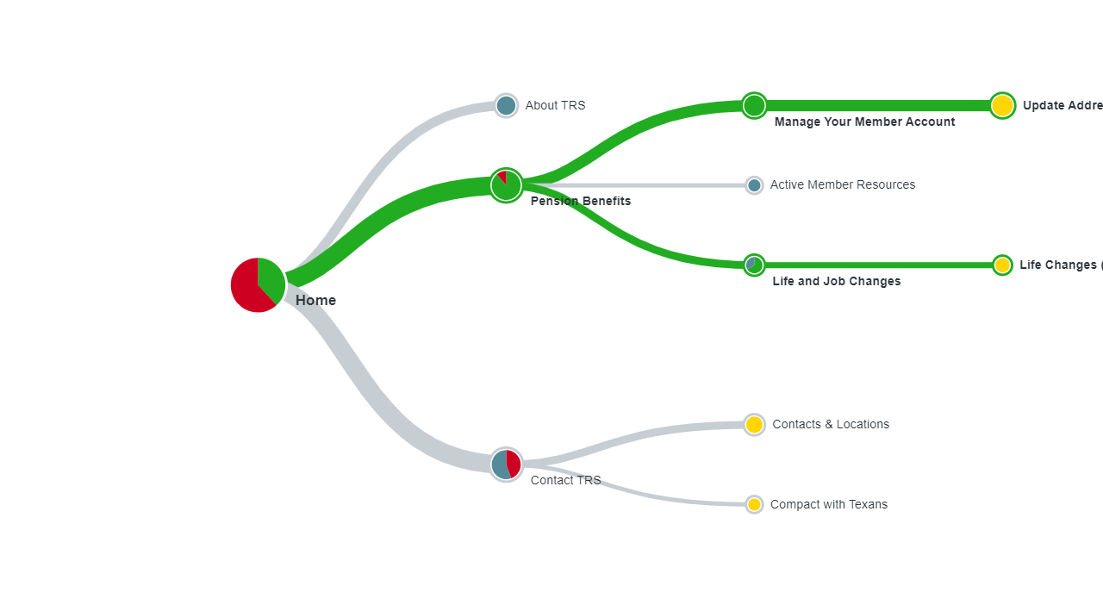
Life and Job Changes featuring in Contacts?

Task 2: You are thinking about buying a new home and are wondering if you can borrow money from your TRS account. Where would you go on the website to find out if this is possible?
Confusing for participants – refund your account seemed like the correct option to many
Contact was a default fallback option

Task 3: You heard in a webinar that TRS has different membership categories called “tiers" and you want to know which tier you belong to. Where will you look for this information?
Know Your TRS Benefits – TRS Retirement Benefits / Know Your Tier (Labeling can be improved here)
Pension Benefits and Contacts were most chosen first clicks
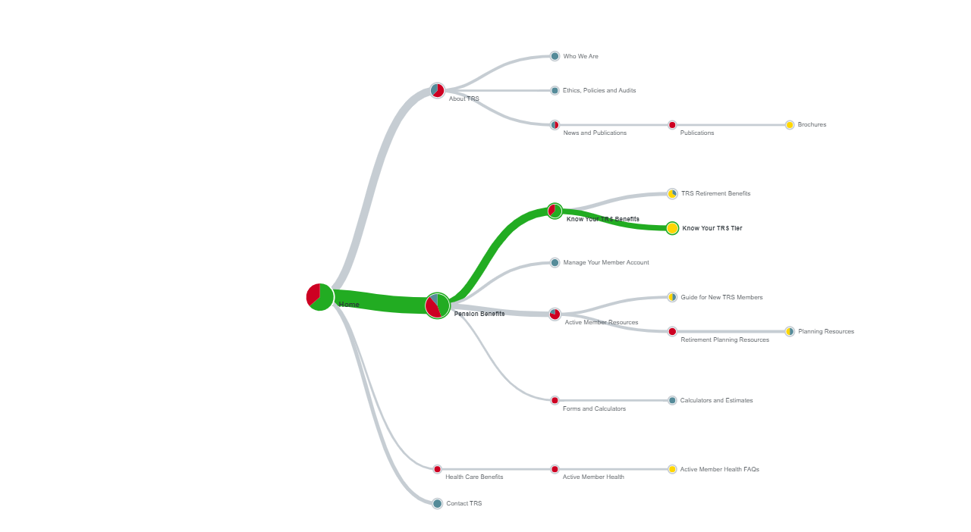

Task 4: You are mid-career and want to improve your retirement benefits by buying service credit. Where would you look on the website to find the costs and the process to buying service credit?
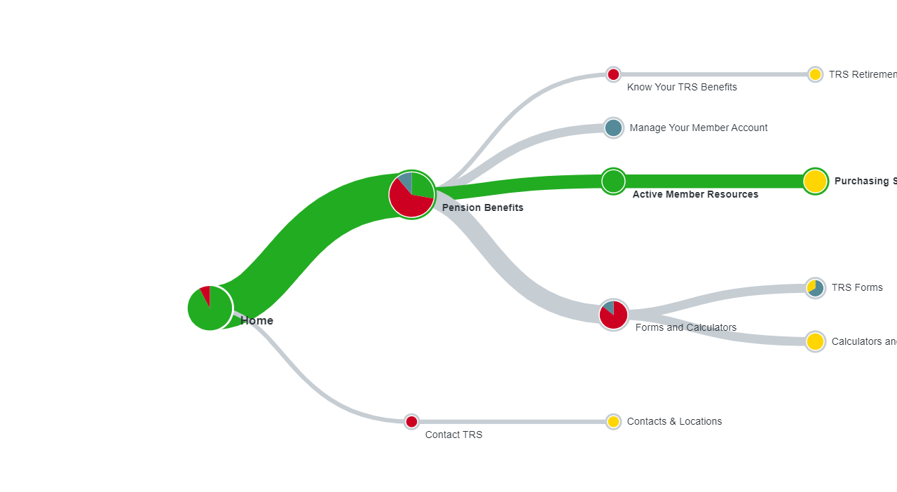
People seem to think of this as an “Action” – Active Member Resources was the second click ONLY in two cases (both of which were Direct Successes)
In both Card Sorting and Tree testing – Service Credit Purchase is associated with Calculators and Estimates for some.

Task 5: You are currently a high school teacher getting ready for your annual health checkup. You want to know what preventive care your TRS health plan includes. Where would you look to find this information?
Best performing Task – even though most nested

Task 6: You recently had a medical claim partially rejected and want to know if you can appeal it. Where would you look on the website?

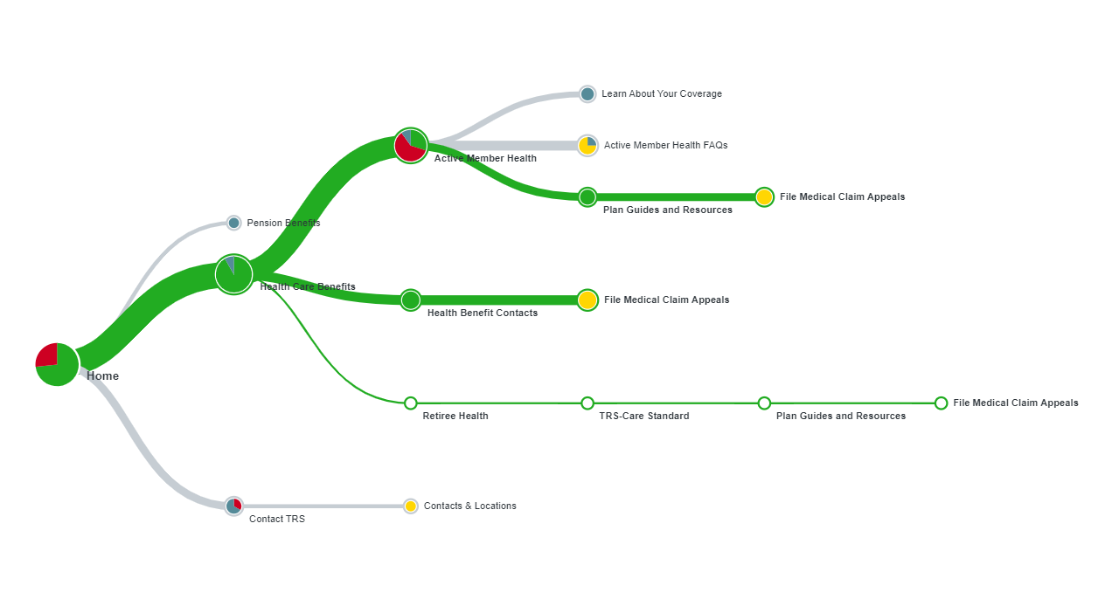

Active Member Health – Most chosen first click – people don’t see Health Contacts as clearly.
One person chose Contacts and Locations - Contacts may need a section on Appeals

In a lots of Health questions – FAQs are often chosen as correct location

Task 7: You're turning 65 soon and will be eligible for TRS-Care Medicare. But before enrolling in it, you want to compare it with other Medicare plans. Where on the website would you check to learn more about this?

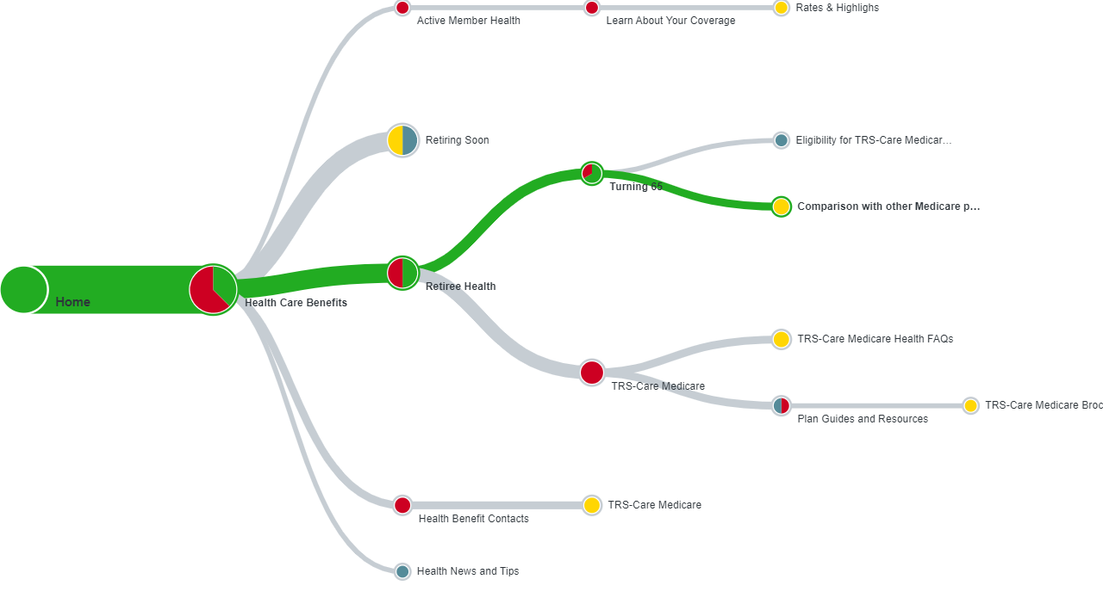

Turning 65 – Retiring Soon.

Task 8: You are looking for information that would be helpful in planning for your retirement with TRS. Where would you go to look for these resources on the website?

Planning resources may need to be more clear – participants confused whether to look at active members or retirees?
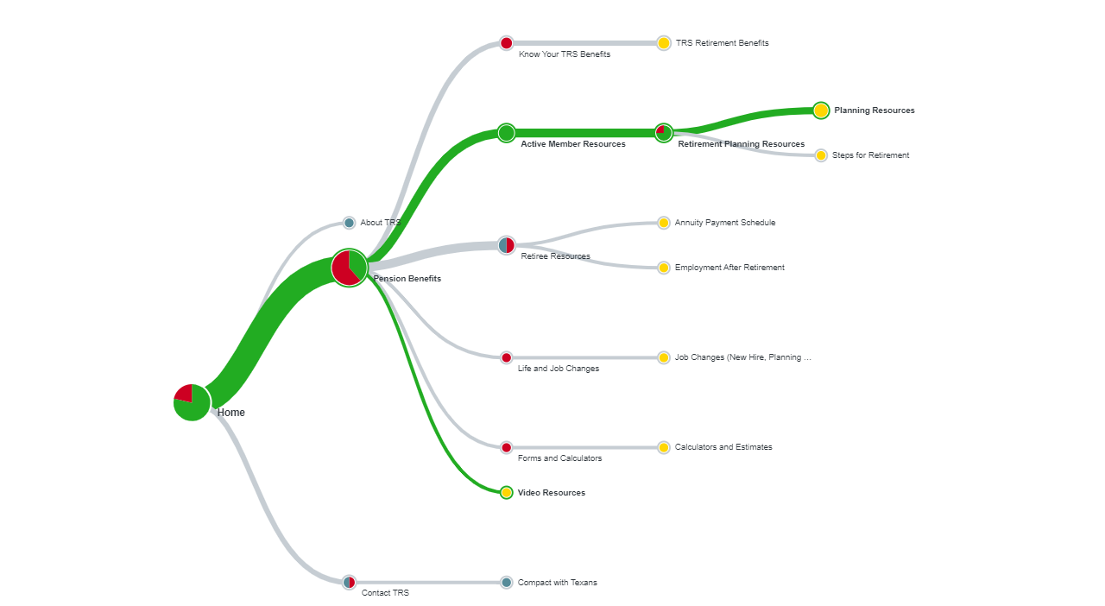

Task 9: You are a beneficiary for a TRS member who recently passed away. You are wondering about the next steps to take to engage with TRS. Where do you look for this information?
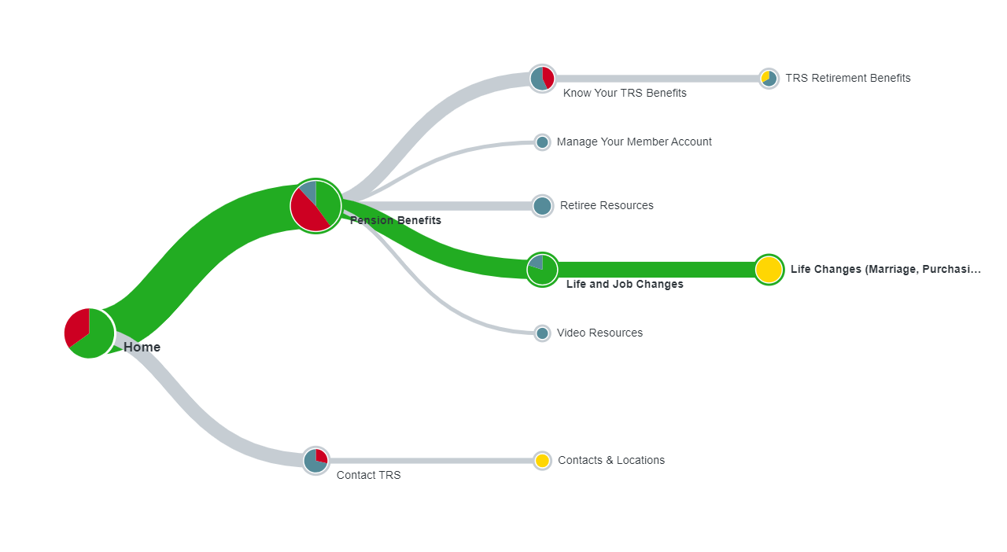
10-7 Life and Job Changes vs Contact TRS.
Retiree Resources also clicked on 4 times.

